Booking Parent
Teacher Interviews (Web)

- To access the parent teacher interviews via the webpage please open the compass website and look for the green banner that says parent teacher interviews, in the top right hand side of the webpage

https://tamworth-h-nsw.compass.education/
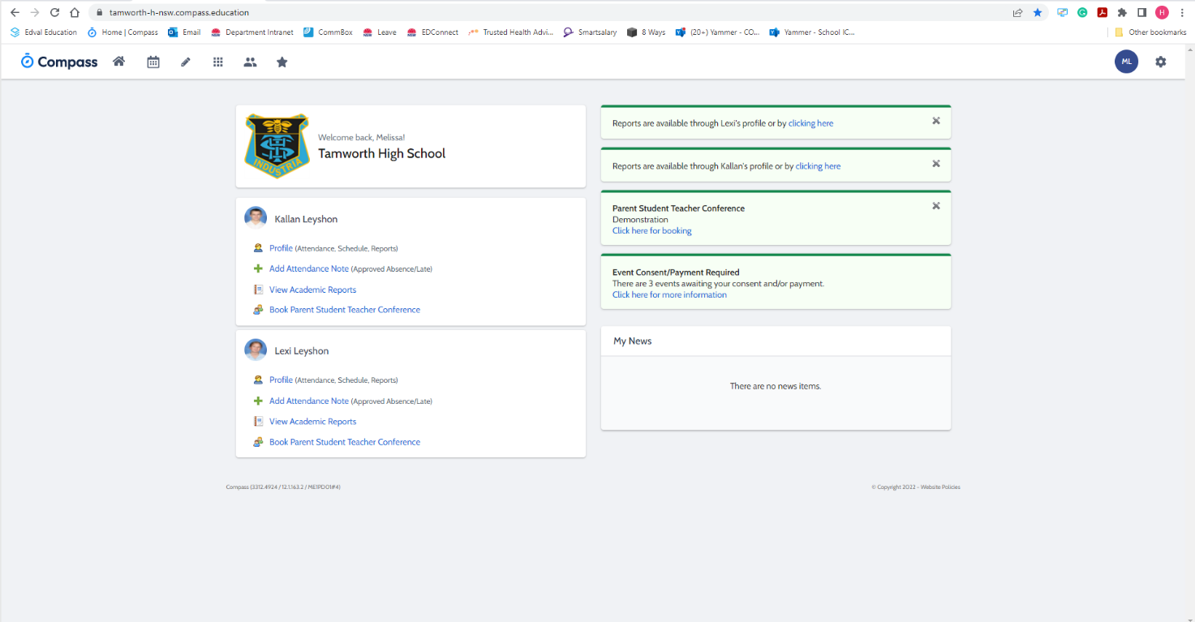

- After this you will be taken to the booking screen where you will be able to see all your available times to book meetings on the night and the teachers that are associated with your child’s class
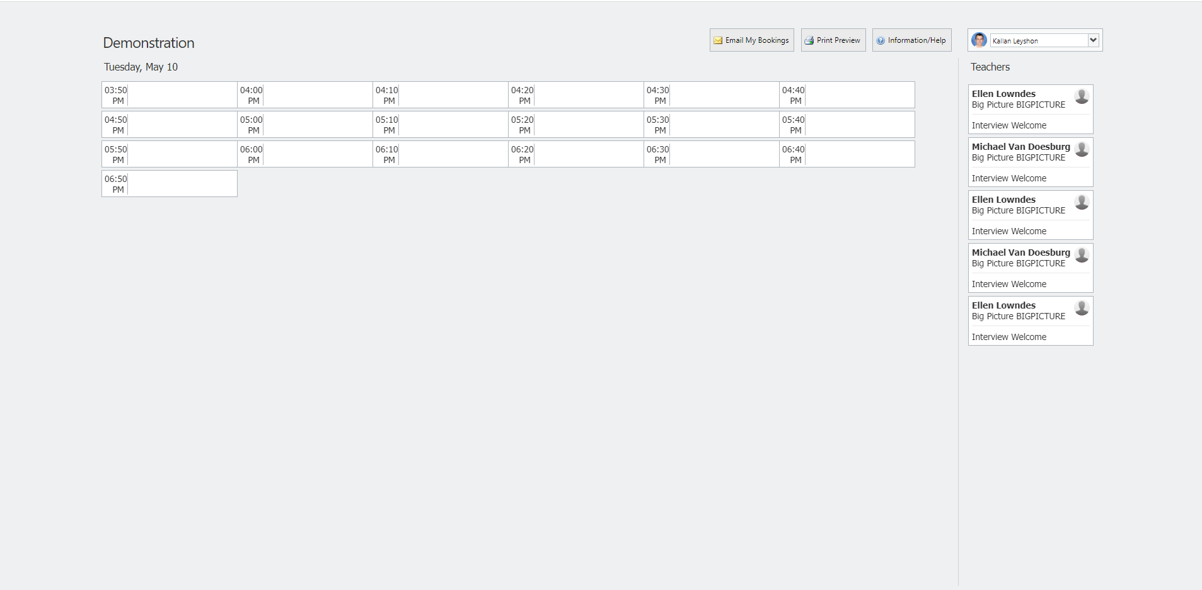

- From the list of available times choose one of the free time slots, from here the teachers that are available to be booked will be highlighted and you select one.

- Lastly confirm that the details are correct and select ok and you have booked in with that teacher

