Booking Parent
Teacher Interviews (App)

- To access the parent teacher interviews via the app please open the app and then choose the option of more as shown in the image below

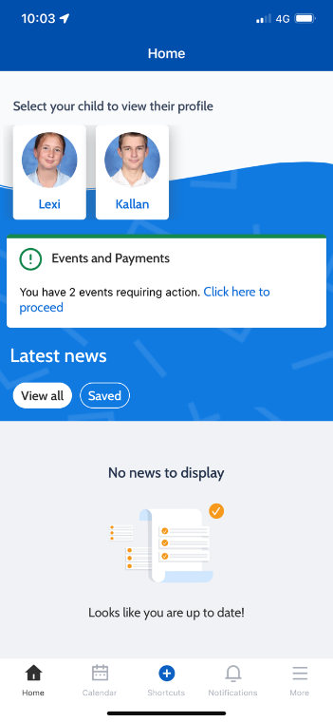

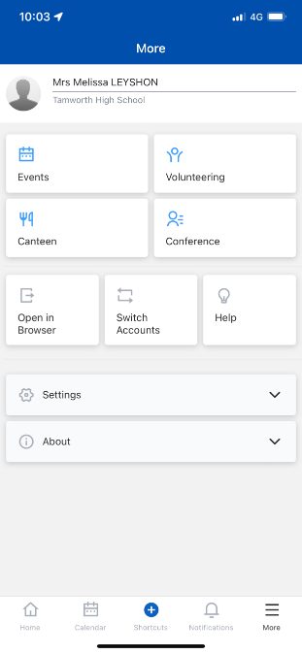
- After this choose the option of conferences:

- Next choose the correct parent teacher interview that you would like to book a meeting in

- Next choose the student that you are booking the interview for

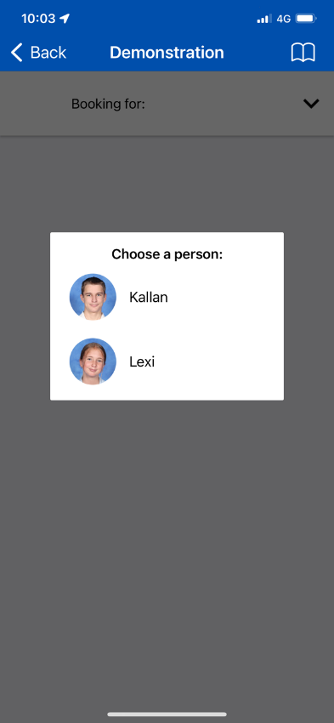

- Next choose the teacher and subject that you would like to make a booking with

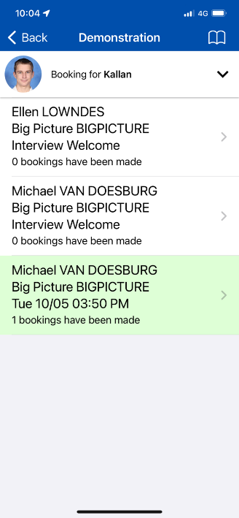

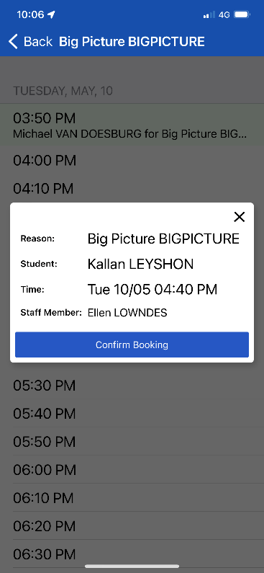
- lastly you will need to choose an appropriate time for the interview. After this you just need to confirm the details and the meeting has been booked
